Bug Report

BUG_ID | BUG_01
Title | UI Error Message overlaps Input Fields and Shows Incorrect Text for Invalid Credentials
Description | On the login page, when entering a invalid username with an invalid password, the error message appears in a red box overlapping the input fields.
Steps | 1- open URL : https://www.saucedemo.com/v1/index.html  2- Enter "stand_user" at username field  3- Enter "sec_sauce" at password field  4- click "Login" button
Expected result: | System login unsuccessful with understandable and centered error "Username and password don’t match any user in this service"
Actual result: | System show error message that contain “Epic sadface: Username and password do not match any user in this service”
Attachment | 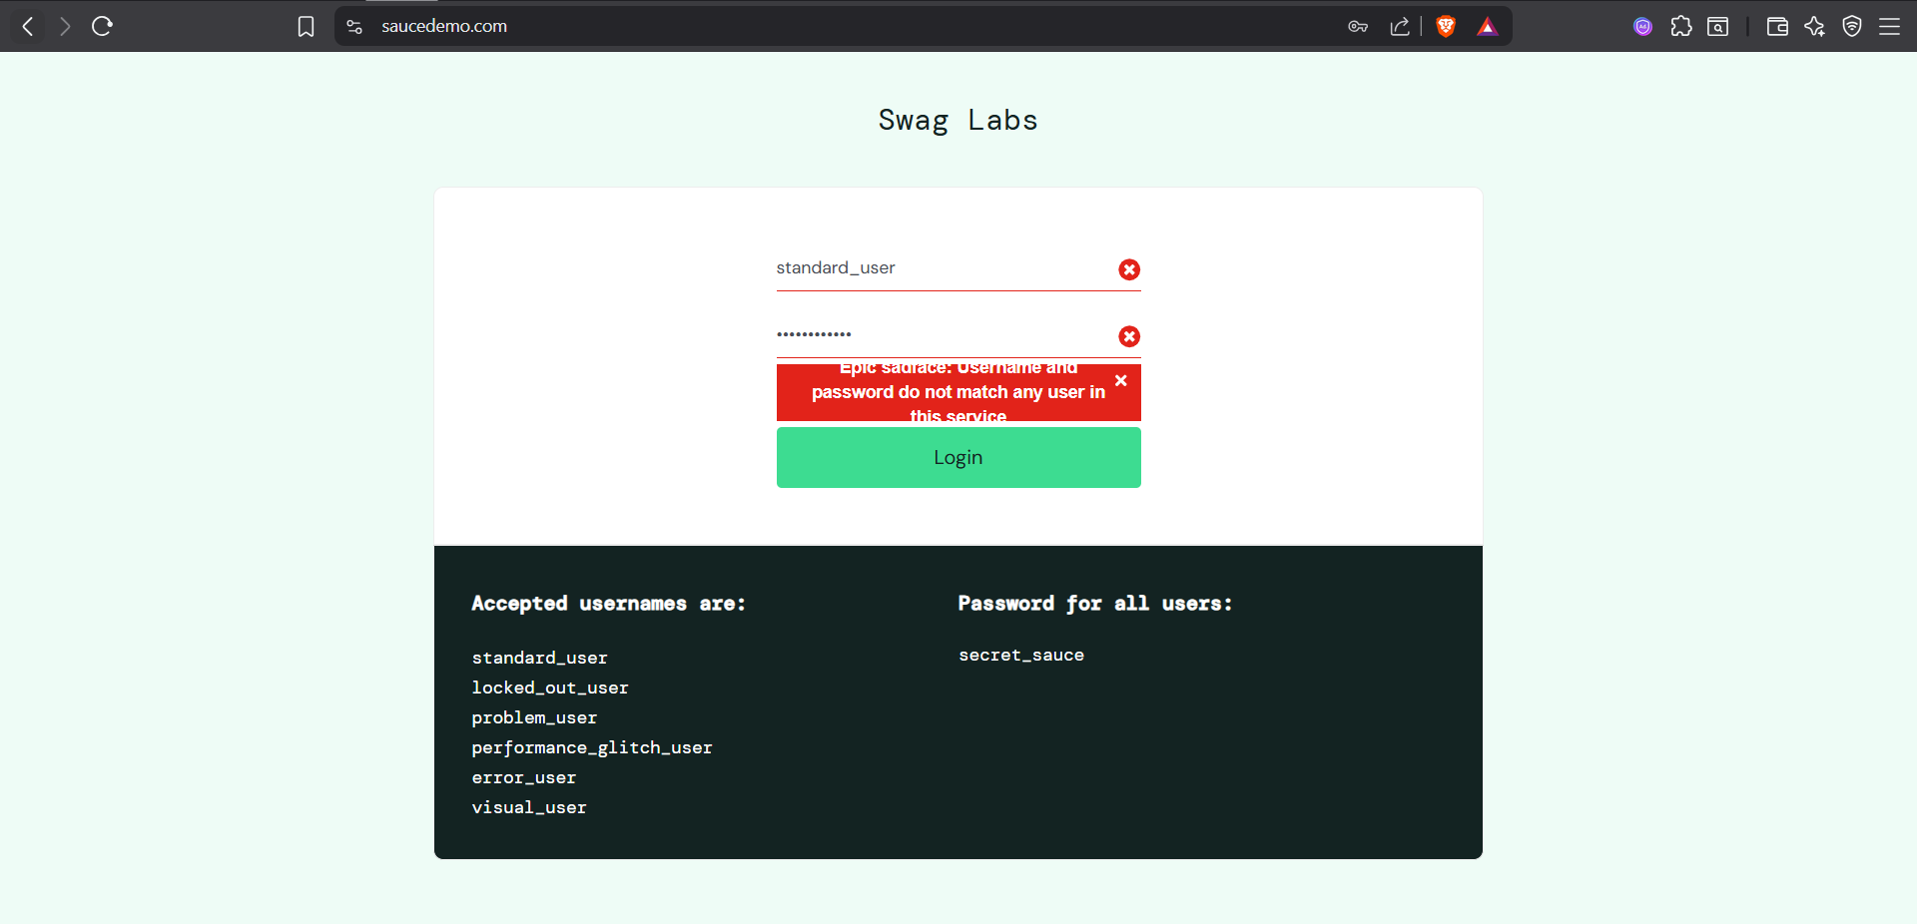
Severity | Low
Priority | Low

BUG_ID | BUG_02
Title | UI Error Message Not Fully Visible for Invalid Password
Description | When an invalid password is entered, the error message is not fully visible and incorrectly describes both username and password as invalid.
Steps | "1- open URL : https://www.saucedemo.com/v1/index.html  2- Enter ""standard_user"" at username field  3- Enter ""_sauce"" at password field  4- click ""Login"" button"
Expected result: | Display a clear error message such as 'Invalid password' without visual issues.
Actual result: | Displays 'Epic sadface: password do not match any user in this service' and the message is partially hidden
Attachment | 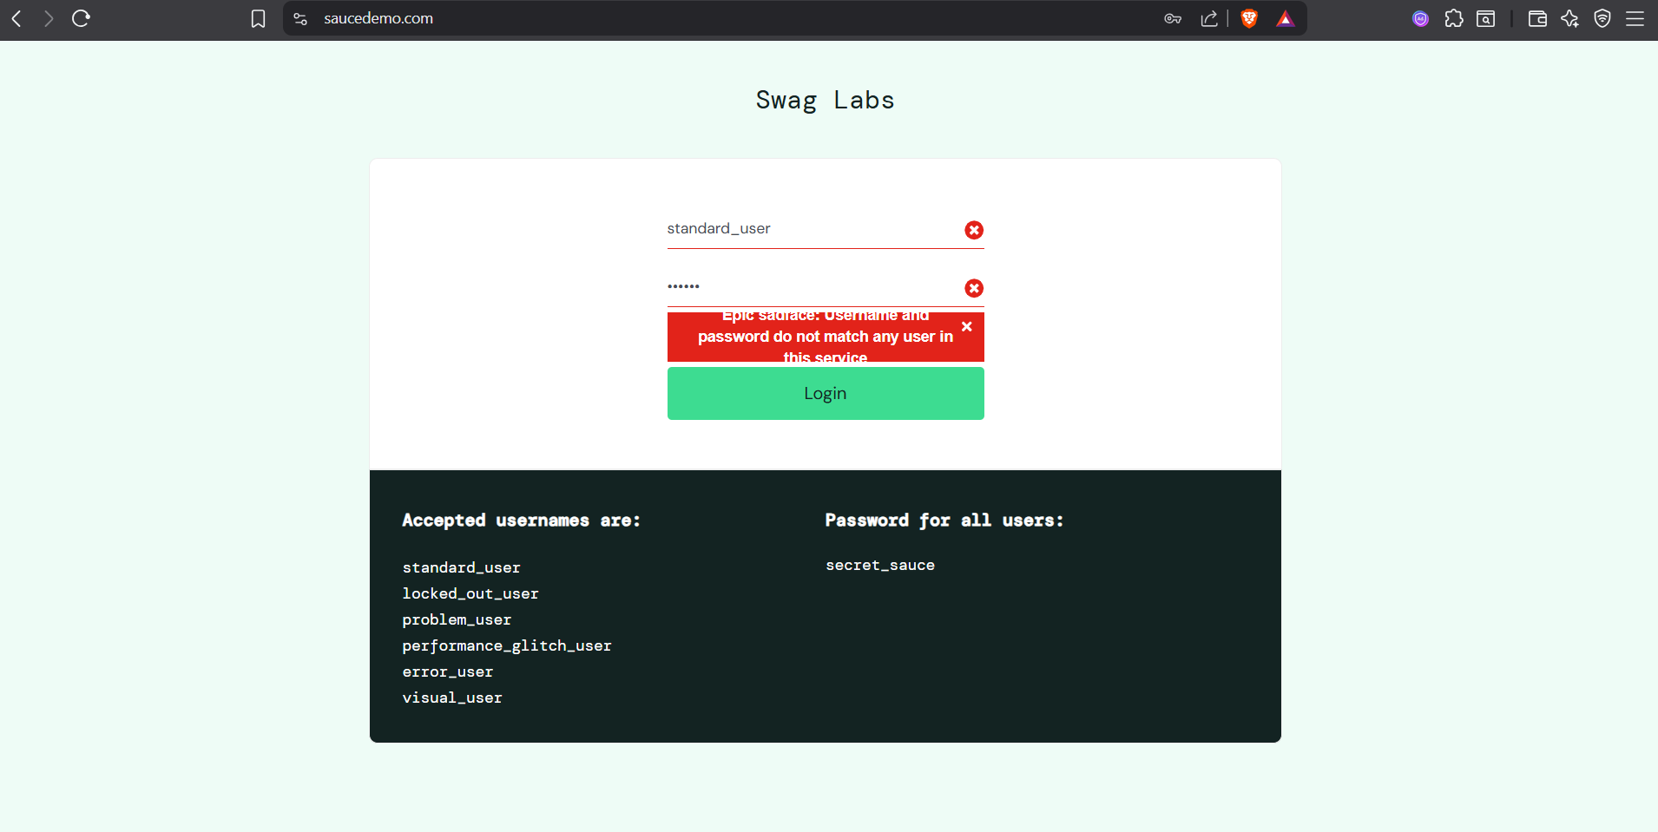
Severity | Low
Priority | Low

BUG_ID | BUG_03
Title | Incorrect Error Message Displayed for Invalid Username
Description | When an invalid username is entered, the error message incorrectly refers to both username and password as invalid and is not fully visible.
Steps | "1- open URL : https://www.saucedemo.com/v1/index.html  2- Enter ""standard_"" at username field  3- Enter ""secert_sauce"" at password field  4- click ""Login"" button"
Expected result: | Should display a clear message such as 'Invalid username.'
Actual result: | Displays 'Epic sadface: password do not match any user in this service' and is partially hidden.
Attachment | 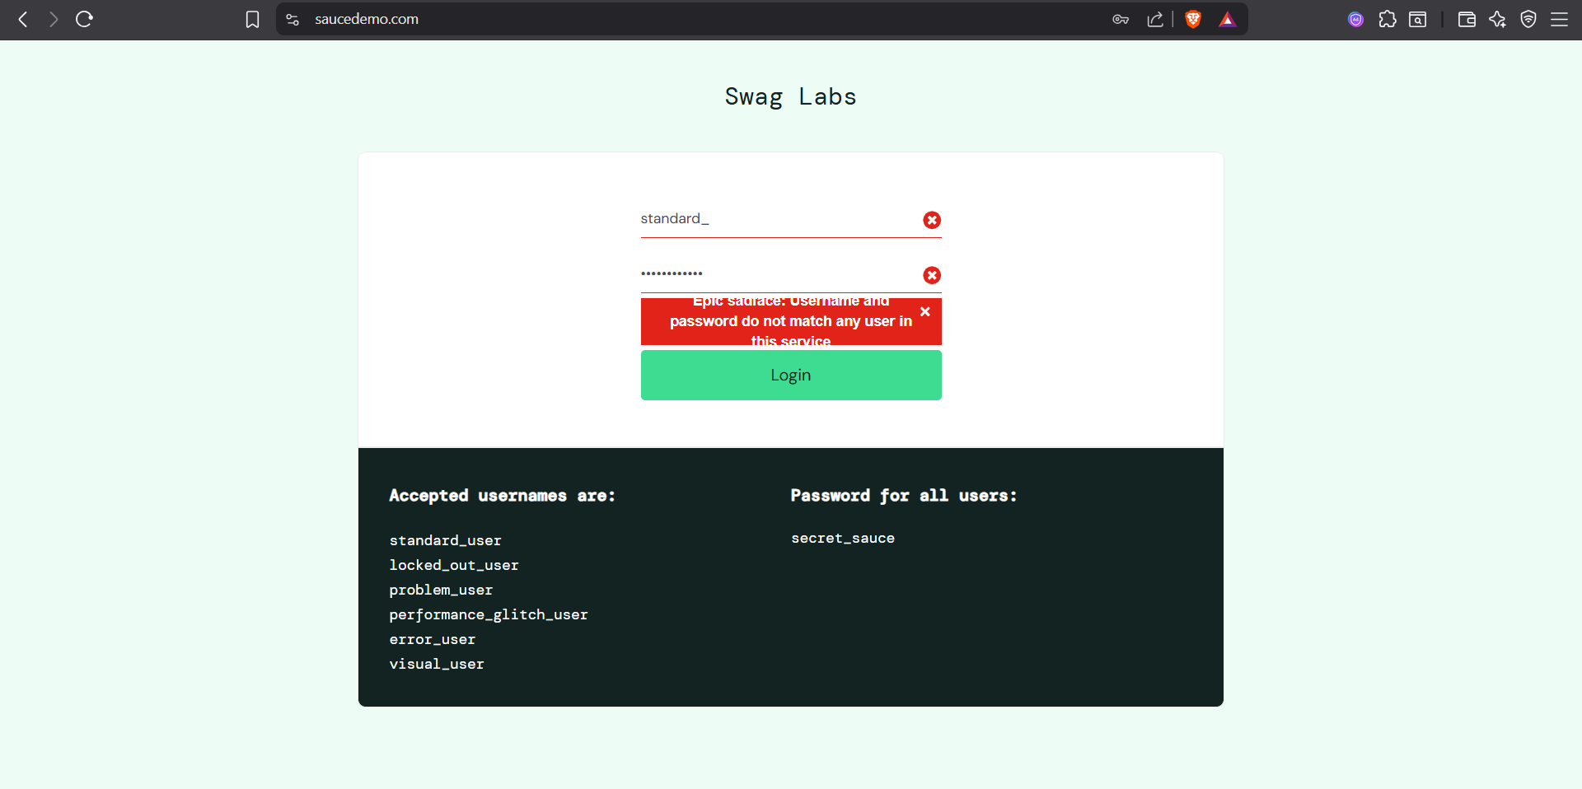
Severity | Low
Priority | Low

BUG_ID | BUG_04
Title | Error Message Persists After Correcting Invalid Credentials
Description | After entering an invalid password and then correcting it, the error message should disappear but remains visible.
Steps | 1- open URL : https://www.saucedemo.com/v1/index.html  2- Enter ""standard_user"" at username field  3- Enter ""_sauce"" at password field  4- click ""Login"" button  5- Enter ""secert_sauce"" at password"
Expected result: | The error message should disappear once the credentials are corrected.
Actual result: | Error message remains visible even after valid credentials are entered.
Attachment | 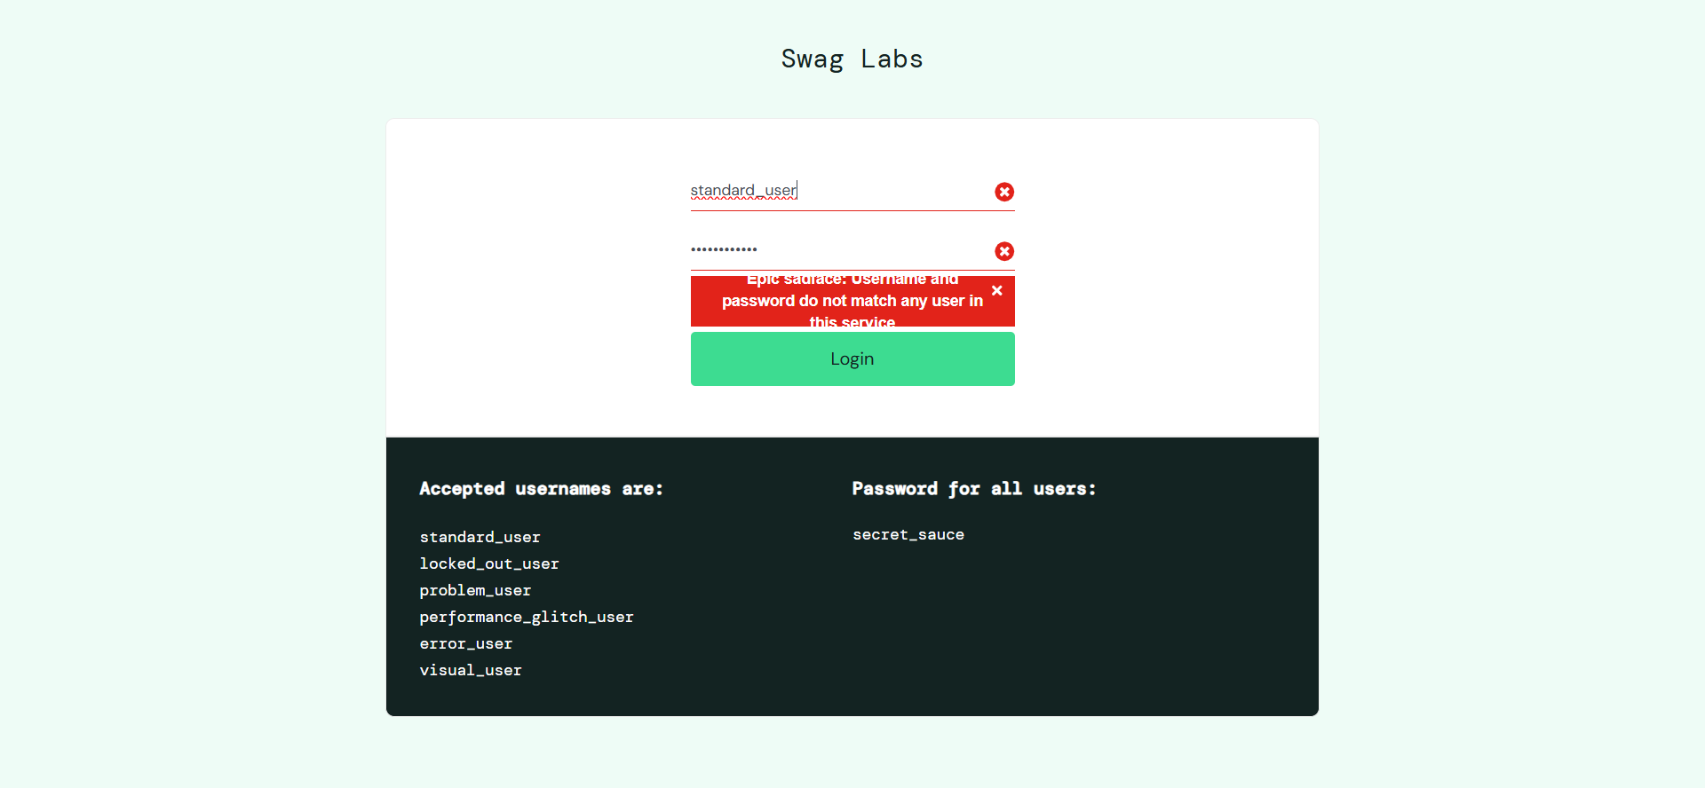
Severity | Low
Priority | Low

BUG_ID | BUG_05
Title | Missing Username Field Validation on Login Page
Description | When both username and password fields are left empty, the error message does not clearly indicate missing input.
Steps | 1- open URL : https://www.saucedemo.com/v1/index.html  2- Enter """" at username field  3- Enter """" at password field  4- click ""Login"" button"
Expected result: | Should display an error message such as 'Username and password required.'
Actual result: | Displays 'Epic sadface: Username is required.'
Attachment | 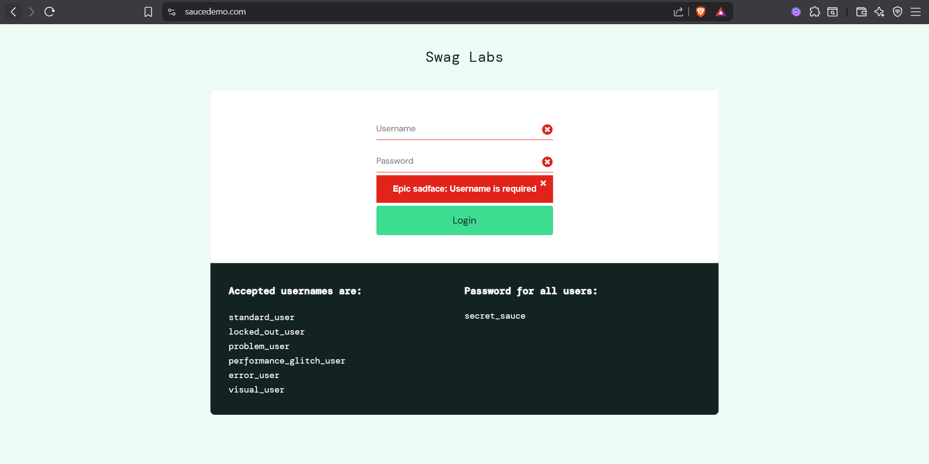
Severity | Medium
Priority | Medium

